
cmp 516 – android programming
dileep mahesh soni T.Y.B.C.A – SEM-VI 2023017001469502


MAY 07,
B.N BANDODKAR COLLEGE OF SCIENCE, THANE
Y.C.M.O.U

Practical no 1

Create Android Application
The first step is to create a simple Android Application using Android studio. When you click on Android studio icon, it will show screen as shown below
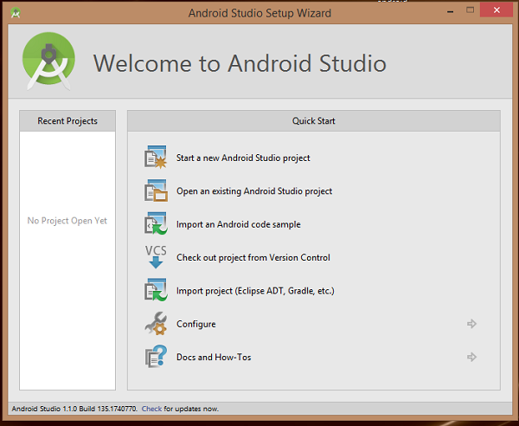
You can start your application development by calling start a new android studio project. in a new installation frame should ask Application name, package information and location of the project.−
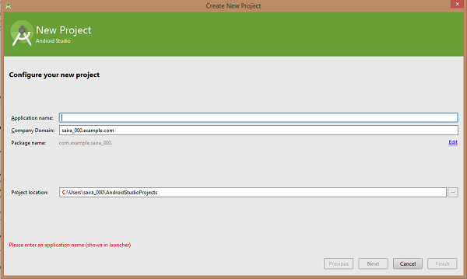
After entered application name, it going to be called select the form factors your application runs on, here need to specify Minimum SDK, in our tutorial, I have declared as API23: Android 6.0(Mashmallow) −
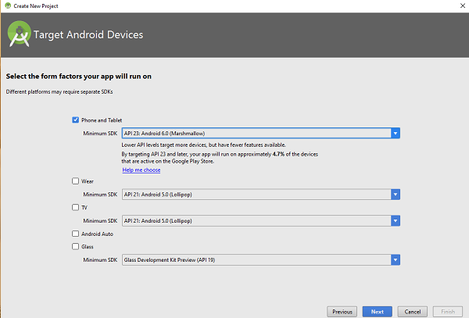
The next level of installation should contain selecting the activity to mobile, it specifies the default layout for Applications.
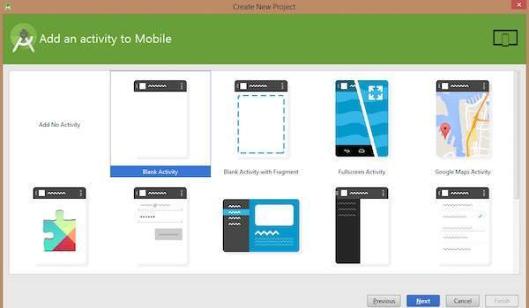
At the final stage it going to be open development tool to write the application code.
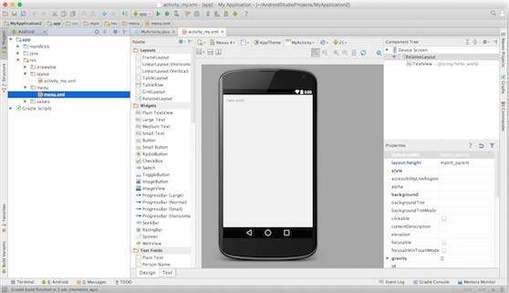

Practical no 2 :
Button and toggle button
<?xml version="1.0" encoding="utf-8"?>
<androidx.constraintlayout.widget.ConstraintLayout
xmlns:android="http://schemas.android.com/apk/res/android"
xmlns:app="http://schemas.android.com/apk/res-auto"
xmlns:tools="http://schemas.android.com/tools"
android:layout_width="match_parent"
android:layout_height="match_parent"
android:background="#168BC34A"
tools:context=".MainActivity">

<!-- Button added in the activity -->
<Button
android:id="@+id/button"
android:layout_width="wrap_content"
android:layout_height="wrap_content"
android:background="#4CAF50"
android:paddingStart="10dp"
android:paddingEnd="10dp"
android:text="@string/btn"
android:textColor="@android:color/background_light"
android:textSize="24sp"
app:layout_constraintBottom_toBottomOf="parent"
app:layout_constraintEnd_toEndOf="parent"
app:layout_constraintStart_toStartOf="parent"
app:layout_constraintTop_toTopOf="parent" />

</androidx.constraintlayout.widget.ConstraintLayout>

import androidx.appcompat.app.AppCompatActivity;
import android.content.Context;
import android.os.Bundle;
import android.view.View;
import android.widget.Button;
import android.widget.Toast;

public class MainActivity extends AppCompatActivity {
@Override // L Code
protected void onCreate( Bundle savedInstanceState ) {
super.onCreate(savedInstanceState);
setContentView(R.layout.activity_main);
// storing ID of the button
// in a variable
Button button = (Button)findViewById(R.id.button);
// operations to be performed
// when user tap on the button
if (button != null) {
button.setOnClickListener((View.OnClickListener)(new View.OnClickListener() {
public final void onClick(View it) {
// displaying a toast message
Toast.makeText((Context)MainActivity.this, R.string.message, Toast.LENGTH_LONG).show();
} })) ; }}}
// S Code yes
Button button = (Button)findViewById(R.id.button);
button.setOnClickListener(view ->
{
Toast.makeText(MainActivity.this, "Button Clicked!",
Toast.LENGTH_SHORT).show();
}) ; }}

Toggle Button :
<RelativeLayout
xmlns:android="http://schemas.android.com/apk/res/android"
xmlns:app="http://schemas.android.com/apk/res-auto"
xmlns:tools="http://schemas.android.com/tools"
android:layout_width="match_parent"
android:layout_height="match_parent"
android:padding="16dp"
android:background="@color/white"
tools:context=".MainActivity">

<ToggleButton
android:id="@+id/toggleButton"
android:layout_width="wrap_content"
android:layout_height="wrap_content"
android:layout_centerHorizontal="true"
android:layout_centerVertical="true"
android:onClick="onToggleClick"
/>
<TextView
android:id="@+id/textView"
android:layout_width="wrap_content"
android:layout_height="wrap_content"
android:layout_marginBottom="100dp"
android:layout_centerVertical="true"
android:layout_centerHorizontal="true"
android:layout_above="@+id/toggleButton"
android:textStyle="bold"
android:textColor="@color/black"/>
</RelativeLayout>

import androidx.appcompat.app.AppCompatActivity; //Basic Imports
import android.os.Bundle;
import android.view.View;
import android.widget.TextView;
import android.widget.ToggleButton;
// L code
public class MainActivity extends AppCompatActivity {

@Override
protected void onCreate(Bundle savedInstanceState) {
super.onCreate(savedInstanceState);
setContentView(R.layout.activity_main);

ToggleButton toggleButton = findViewById(R.id.toggleButton);
final TextView textView = findViewById(R.id.textView);

toggleButton.setOnCheckedChangeListener(new CompoundButton.OnCheckedChangeListener() {
@SuppressLint("SetTextI18n")
public void onCheckedChanged(@NonNull CompoundButton buttonView, boolean isChecked) {
if (isChecked) {
textView.setText("Toggle is ON"); }
else
{textView.setText("Toggle is OFF");
}
}
});
} }
// S CODE
setContentView(R.layout.activity_main);
ToggleButton btn = findViewById(R.id.toggleButton);
TextView txt = findViewById(R.id.textView);
btn.setOnCheckedChangeListener((view, isChecked) -> {
txt.setText(isChecked ? "Toggle is ON" : "Toggle is OFF"); });

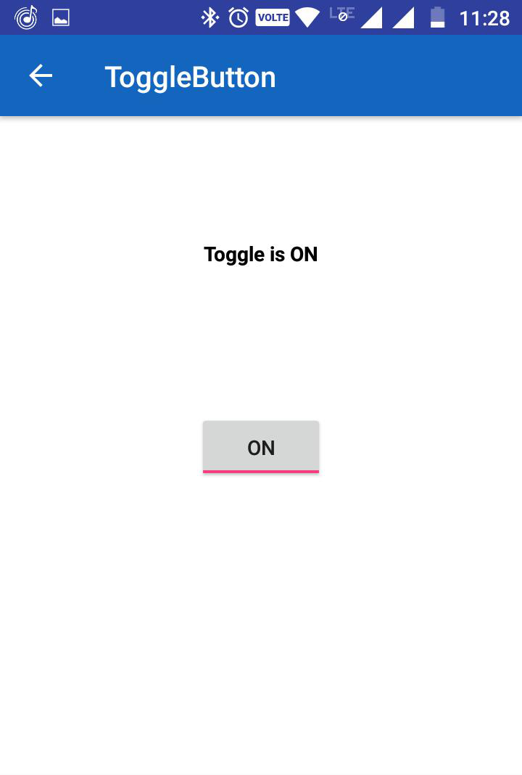
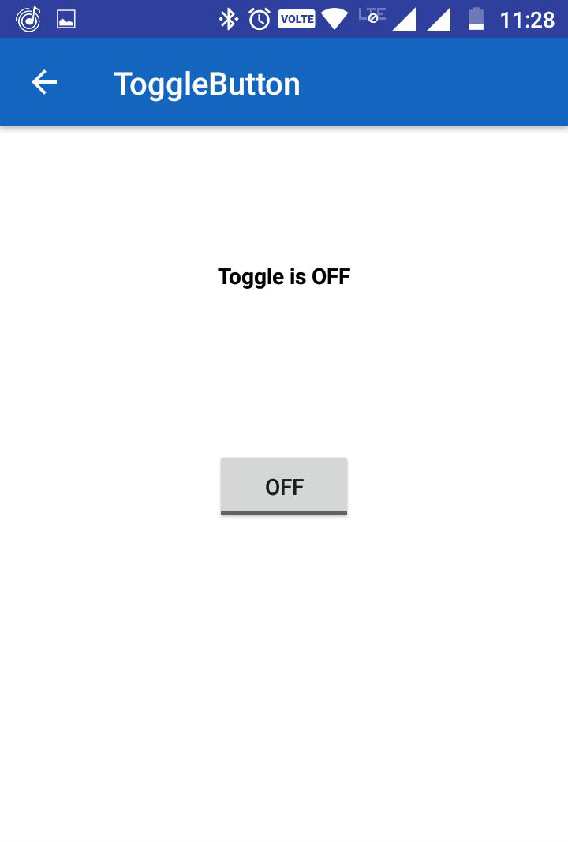
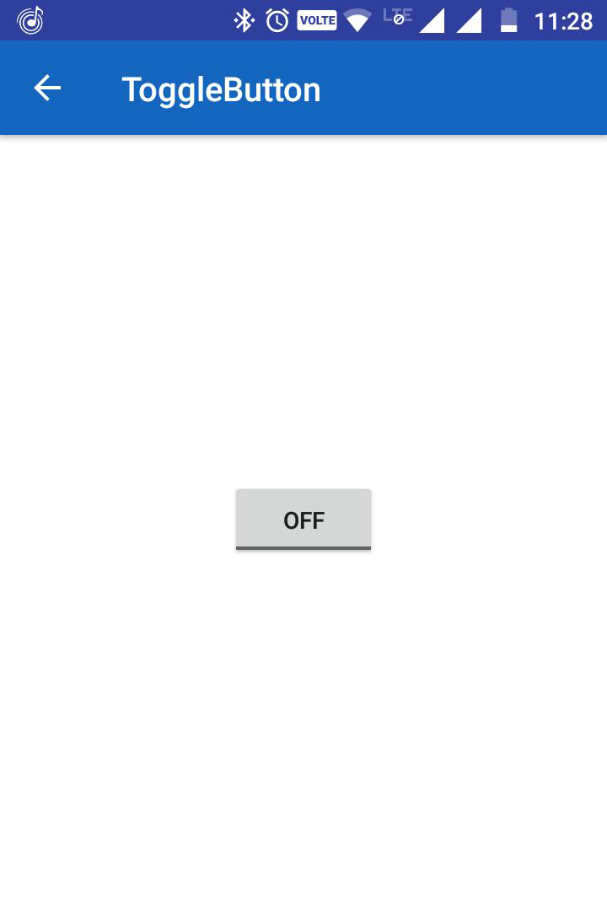

Practical no 3 :
Toast Message
import android.support.v7.app.AppCompatActivity;
import android.os.Bundle;
import android.view.View;
import android.widget.Button;
import android.widget.Toast;

public class MainActivity extends AppCompatActivity {
// Defining the object for button
Button btn;

@Override
protected void onCreate(Bundle savedInstanceState) {
super.onCreate(savedInstanceState);
setContentView(R.layout.activity_main);
// L CODE
// Bind the components to their respective objects by assigning
// their IDs with the help of findViewById() method
Button btn = (Button)findViewById(R.id.Button01);

btn.setOnClickListener(new View.OnClickListener() {
@Override
public void onClick(View v) {
// Displaying simple Toast message
Toast.makeText(getApplicationContext(), "This a toast message", Toast.LENGTH_LONG).show();
}
});
}
}
// S Code
setContentView(R.layout.activity_main);

// Using a Lambda expression to replace the anonymous class
findViewById(R.id.button).setOnClickListener(v ->
Toast.makeText(this, "This is a Toast Message", Toast.LENGTH_LONG).show()
); }}
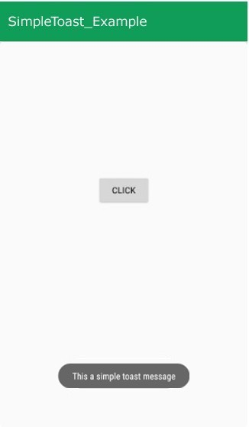

Practical 4
ALERT DIALOUGE BOX

package com.example.thirdapp; // basic imports from here

import android.app.AlertDialog;
import android.os.Bundle;
import android.util.Log;
import android.widget.CheckBox;

import androidx.activity.OnBackPressedCallback;
import androidx.appcompat.app.AppCompatActivity; // to here

public class MainActivity extends AppCompatActivity {

@Override // inside On Create
protected void onCreate(Bundle savedInstanceState) {
super.onCreate(savedInstanceState);
setContentView(R.layout.activity_main);

// Tomato Checkbox // CSH
CheckBox tomato = findViewById(R.id.checkBox);
tomato.setOnCheckedChangeListener((buttonView, isChecked) -> {
Log.d("CHECKBOXES", "Tomato is checked: " + isChecked);
});

// Cheese Checkbox
CheckBox cheese = findViewById(R.id.checkBox2);
cheese.setOnCheckedChangeListener((buttonView, isChecked) -> {
Log.d("CHECKBOXES", "Cheese is checked: " + isChecked); // on Create ends here
});

// Modern back press handling //Outside oncreate
getOnBackPressedDispatcher().addCallback(this, new OnBackPressedCallback(true) {
@Override
public void handleOnBackPressed() {
new AlertDialog.Builder(MainActivity.this)
.setTitle("Alert!")
.setMessage("Do you want to exit?")
.setCancelable(false)
.setPositiveButton("Yes", (d, w) -> finish())
.setNegativeButton("No", (d, w) -> d.dismiss())
.show();
}
});
}
}

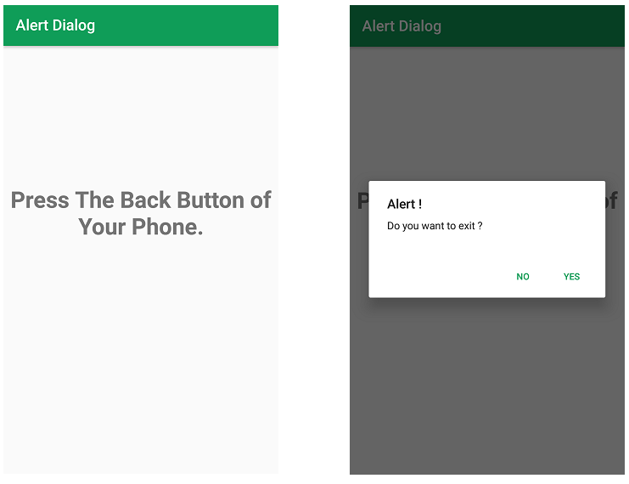

Practical No 5 Spinner
Layout –
<?xml version="1.0" encoding="utf-8"?>
<RelativeLayout xmlns:android="http://schemas.android.com/apk/res/android"
xmlns:tools="http://schemas.android.com/tools"
android:id="@+id/main"
android:layout_width="match_parent"
android:layout_height="match_parent"
android:background="#A0E793"
tools:context=".MainActivity">

<Spinner
android:id="@+id/spinner"
android:layout_width="287dp"
android:layout_height="124dp"
android:layout_alignParentStart="true"
android:layout_alignParentEnd="true"
android:layout_alignParentBottom="true"
android:layout_marginStart="51dp"
android:layout_marginEnd="72dp"
android:layout_marginBottom="405dp" />
</RelativeLayout>
import android.os.Bundle; // Basic Imports
import android.view.View;
import android.widget.AdapterView;
import android.widget.ArrayAdapter;
import android.widget.Spinner;
import android.widget.Toast;
import androidx.appcompat.app.AppCompatActivity;

public class MainActivity extends AppCompatActivity implements AdapterView.OnItemSelectedListener {
String[] courses = {"C", "Java", "Python", "Algorithms", "OS"};
@Override // code starts here
protected void onCreate(Bundle savedInstanceState) {
super.onCreate(savedInstanceState);
setContentView(R.layout.activity_main);
Spinner spin = findViewById(R.id.spinner); // Spinner Starts
// 1. Create Adapter (Context, Layout, Data)
ArrayAdapter ad = new ArrayAdapter(this, android.R.layout.simple_spinner_item, courses);
ad.setDropDownViewResource(android.R.layout.simple_spinner_dropdown_item);
// 2. Bind Adapter and Listener to Spinner
spin.setAdapter(ad);
spin.setOnItemSelectedListener(this);
}
@Override // Toast
public void onItemSelected(AdapterView<?> parent, View view, int position, long id) {
// Show a Toast message of the selected item
Toast.makeText(this, courses[position], Toast.LENGTH_SHORT).show();
}
@Override // 1 item need to be selected
public void onNothingSelected(AdapterView<?> parent) {
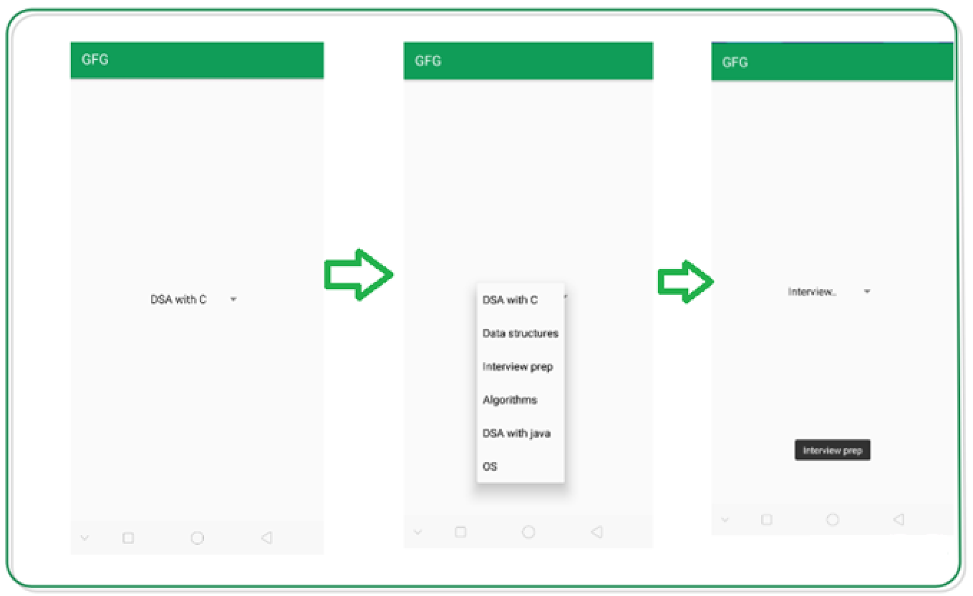
// Leave empty - usually not needed bp
} }

Auto Complete Text View
Layout – // layout for AutoComp

<?xml version="1.0" encoding="utf-8"?>
<androidx.constraintlayout.widget.ConstraintLayout
xmlns:android="http://schemas.android.com/apk/res/android"
xmlns:app="http://schemas.android.com/apk/res-auto"
xmlns:tools="http://schemas.android.com/tools"
android:id="@+id/main"
android:layout_width="match_parent"
android:layout_height="match_parent"
tools:context=".MainActivity">

<AutoCompleteTextView
android:id="@+id/autoCompleteTextView"
android:layout_width="239dp"
android:layout_height="91dp"
android:layout_marginTop="76dp"
android:text="Enter Course Name"
android:textSize="20sp"
app:layout_constraintEnd_toEndOf="parent"
app:layout_constraintStart_toStartOf="parent"
app:layout_constraintTop_toTopOf="parent" />

</androidx.constraintlayout.widget.ConstraintLayout>
import android.graphics.Color; // Basic Imports
import android.os.Bundle;
import android.widget.ArrayAdapter;
import android.widget.AutoCompleteTextView;
import androidx.appcompat.app.AppCompatActivity;

public class MainActivity extends AppCompatActivity {

String[] language ={"C","C++","Java",".NET","iPhone","Android","ASP.NET","PHP"}; // Course

@Override
protected void onCreate(Bundle savedInstanceState) {
super.onCreate(savedInstanceState);
setContentView(R.layout.activity_main);

//Creating the instance of ArrayAdapter containing list of language names //Starts here
ArrayAdapter<String> adapter = new ArrayAdapter<>
(this,android.R.layout.select_dialog_item,language);

//Getting the instance of AutoCompleteTextView
AutoCompleteTextView actv = findViewById(R.id.autoCompleteTextView);
actv.setThreshold(1);//will start working from first character
actv.setAdapter(adapter);//setting the adapter data into the AutoCompleteTextView
actv.setTextColor(Color.RED);
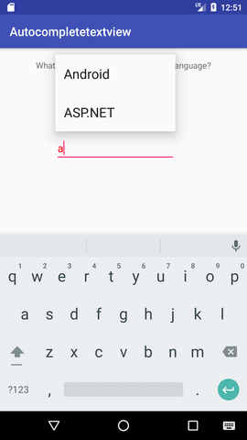
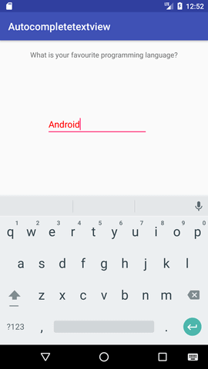
}
}

Practical No 6 Calculator in android
LAYOUT :-
<?xml version="1.0" encoding="utf-8"?>
<androidx.constraintlayout.widget.ConstraintLayout
xmlns:android="http://schemas.android.com/apk/res/android"
xmlns:app="http://schemas.android.com/apk/res-auto"
android:layout_width="match_parent"
android:layout_height="match_parent"
android:padding="20dp">

<EditText
android:id="@+id/n1"
android:layout_width="371dp"
android:layout_height="70dp"
android:hint="Number 1"
android:inputType="numberDecimal"
app:layout_constraintEnd_toEndOf="parent"
app:layout_constraintStart_toStartOf="parent"
app:layout_constraintTop_toTopOf="parent" />

<EditText
android:id="@+id/n2"
android:layout_width="371dp"
android:layout_height="62dp"
android:layout_marginTop="12dp"
android:hint="Number 2"
android:inputType="numberDecimal"
app:layout_constraintEnd_toEndOf="parent"
app:layout_constraintHorizontal_bias="0.0"
app:layout_constraintStart_toStartOf="parent"
app:layout_constraintTop_toBottomOf="@id/n1" />

<!-- Button Row -->
<Button
android:id="@+id/btnAdd"
android:layout_width="wrap_content"
android:layout_height="wrap_content"
android:layout_marginTop="20dp"
android:onClick="doMath"
android:text="+"
app:layout_constraintEnd_toStartOf="@+id/btnSub"
app:layout_constraintHorizontal_chainStyle="spread"
app:layout_constraintStart_toStartOf="parent"
app:layout_constraintTop_toBottomOf="@id/n2" />
<Button
android:id="@+id/btnSub"
android:layout_width="wrap_content"
android:layout_height="wrap_content"
android:layout_marginTop="20dp"
android:onClick="doMath"
android:text="-"
app:layout_constraintEnd_toStartOf="@+id/btnMul"
app:layout_constraintStart_toEndOf="@id/btnAdd"
app:layout_constraintTop_toBottomOf="@id/n2" />
<Button
android:id="@+id/btnMul"
android:layout_width="wrap_content"
android:layout_height="wrap_content"
android:layout_marginTop="20dp"
android:onClick="doMath"
android:text="*"
app:layout_constraintEnd_toStartOf="@+id/btnDiv"
app:layout_constraintStart_toEndOf="@id/btnSub"
app:layout_constraintTop_toBottomOf="@id/n2" />

<Button
android:id="@+id/btnDiv"
android:layout_width="wrap_content"
android:layout_height="wrap_content"
android:layout_marginTop="20dp"
android:onClick="doMath"
android:text="/"
app:layout_constraintEnd_toEndOf="parent"
app:layout_constraintStart_toEndOf="@id/btnMul"
app:layout_constraintTop_toBottomOf="@id/n2" />

<TextView
android:id="@+id/res"
android:layout_width="160dp"
android:layout_height="67dp"
android:layout_marginTop="12dp"
android:text="Result: 0"
android:textSize="24sp"
app:layout_constraintEnd_toEndOf="parent"
app:layout_constraintHorizontal_bias="0.497"
app:layout_constraintStart_toStartOf="parent"
app:layout_constraintTop_toBottomOf="@id/btnAdd" />
</androidx.constraintlayout.widget.ConstraintLayout>
CODE:- // Basic Import
import android.os.Bundle;
import android.view.View;
import android.widget.Button;
import android.widget.EditText;
import android.widget.TextView;

import androidx.appcompat.app.AppCompatActivity;

public class MainActivity extends AppCompatActivity { // Code starts here
EditText e1, e2;
TextView tv;

@Override
protected void onCreate(Bundle b) {
super.onCreate(b);
setContentView(R.layout.activity_main);

e1 = findViewById(R.id.n1);
e2 = findViewById(R.id.n2);
tv = findViewById(R.id.res);
}
public void doMath(View v) {
// 1. Get input as strings and convert to double
double a = Double.parseDouble(e1.getText().toString());
double b = Double.parseDouble(e2.getText().toString());

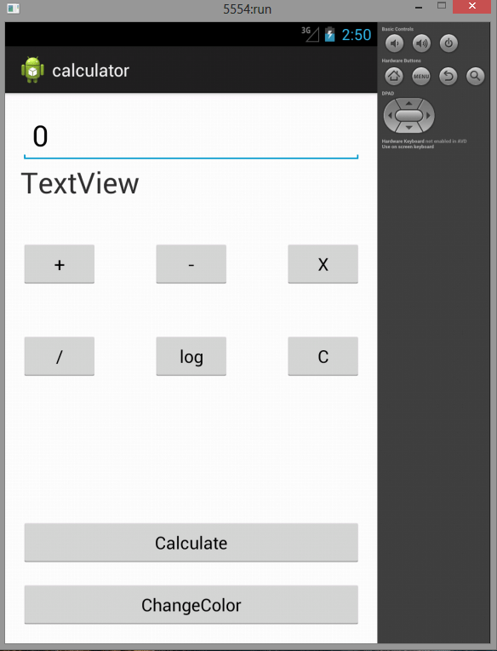
// 2. Identify which button was clicked by its text
String op = ((Button) v).getText().toString();
double r = 0;

// 3. Calculation Logic
if (op.equals("+")) r = a + b;
else if (op.equals("-")) r = a - b;
else if (op.equals("*")) r = a * b;
else if (op.equals("/")) r = a / b;

// 4. Display result
tv.setText("Result: " + r);
}
}

Practical No 7 -
Rating Bar In Android , WebView
& Seek Bar

<?xml version="1.0" encoding="utf-8"?>
<androidx.constraintlayout.widget.ConstraintLayout
xmlns:android="http://schemas.android.com/apk/res/android"
xmlns:app="http://schemas.android.com/apk/res-auto"
xmlns:tools="http://schemas.android.com/tools"
android:id="@+id/main"
android:layout_width="match_parent"
android:layout_height="match_parent"
android:background="#BFDB9D"
tools:context=".MainActivity">

<RatingBar
android:id="@+id/ratingBar"
android:layout_width="wrap_content"
android:layout_height="wrap_content"
android:layout_marginTop="128dp"
app:layout_constraintEnd_toEndOf="parent"
app:layout_constraintHorizontal_bias="0.438"
app:layout_constraintStart_toStartOf="parent"
app:layout_constraintTop_toTopOf="parent" />

<TextView
android:id="@+id/textView"
android:layout_width="307dp"
android:layout_height="63dp"
android:layout_marginTop="40dp"
android:text="Rate your Experience"
android:textSize="30sp" />
<Button
android:id="@+id/button"
android:layout_width="184dp"
android:layout_height="89dp"
android:layout_marginTop="212dp"
android:text="Submit"
android:textSize="30sp"
app:layout_constraintEnd_toEndOf="parent"
app:layout_constraintHorizontal_bias="0.497"
app:layout_constraintStart_toStartOf="parent"
app:layout_constraintTop_toTopOf="parent" />

<WebView // web view
android:id="@+id/web"
android:layout_width="412dp"
android:layout_height="323dp"
android:layout_marginTop="404dp"
app:layout_constraintEnd_toEndOf="parent"
app:layout_constraintHorizontal_bias="1.0"
app:layout_constraintStart_toStartOf="parent"
app:layout_constraintTop_toTopOf="parent"
android:name="android.permission.INTERNET" />
</androidx.constraintlayout.widget.ConstraintLayout>
import android.os.Bundle; // Basic Imports
import android.support.v7.app.AppCompatActivity;
import android.widget.Button;
import android.widget.RatingBar;
import android.widget.Toast;
public class MainActivity extends AppCompatActivity {

@Override
protected void onCreate(Bundle savedInstanceState) {
super.onCreate(savedInstanceState);
setContentView(R.layout.activity_main);
RatingBar ratingBar = findViewById(R.id.ratingBar); // S Code
Button button = findViewById(R.id.button);
button.setOnClickListener(v -> {
String rating = String.valueOf(ratingBar.getRating());
Toast.makeText(MainActivity.this, rating, Toast.LENGTH_LONG).show();
});

WebView webView = findViewById(R.id.web); // web view additional
webView.setWebViewClient(new WebViewClient());
webView.getSettings().setJavaScriptEnabled(true);
webView.loadUrl("https://www.geeksforgeeks.org");

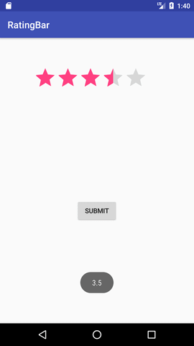
} }

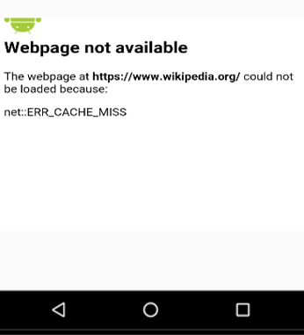

Seek bar
<?xml version="1.0" encoding="utf-8"?>
<androidx.constraintlayout.widget.ConstraintLayout
xmlns:android="http://schemas.android.com/apk/res/android"
xmlns:app="http://schemas.android.com/apk/res-auto"
xmlns:tools="http://schemas.android.com/tools"
android:id="@+id/main"
android:layout_width="match_parent"
android:layout_height="match_parent"
tools:context=".MainActivity">
<SeekBar
android:id="@+id/seekBar"
android:layout_width="234dp"
android:layout_height="87dp"
android:layout_marginTop="188dp"
app:layout_constraintEnd_toEndOf="parent"
app:layout_constraintHorizontal_bias="0.497"
app:layout_constraintStart_toStartOf="parent"
app:layout_constraintTop_toTopOf="parent" />
<TextView
android:id="@+id/textView"
android:layout_width="226dp"
android:layout_height="83dp"
android:layout_marginTop="56dp"
android:text="Slide the Bar"
android:textSize="30sp"
app:layout_constraintHorizontal_bias="0.475"
app:layout_constraintTop_toTopOf="parent" />
</androidx.constraintlayout.widget.ConstraintLayout>

import android.os.Bundle;
import android.widget.SeekBar;
import android.widget.Toast;
import androidx.appcompat.app.AppCompatActivity;
public class MainActivity extends AppCompatActivity {
@Override
protected void onCreate(Bundle savedInstanceState) {
super.onCreate(savedInstanceState);
setContentView(R.layout.activity_main);
SeekBar seekBar = findViewById(R.id.seekBar); // Starts Here
seekBar.setOnSeekBarChangeListener(new SeekBar.OnSeekBarChangeListener() {
@Override
public void onProgressChanged(SeekBar sb, int p, boolean fromUser) {
// This is the only part we usually care about
Toast.makeText(MainActivity.this, "Value: " + p, Toast.LENGTH_SHORT).show();
}
@Override public void onStartTrackingTouch(SeekBar sb) {
Toast.makeText(MainActivity.this, "Started!", Toast.LENGTH_SHORT).show();
}
@Override public void onStopTrackingTouch(SeekBar sb) {
Toast.makeText(MainActivity.this, "Stopped!", Toast.LENGTH_SHORT).show();
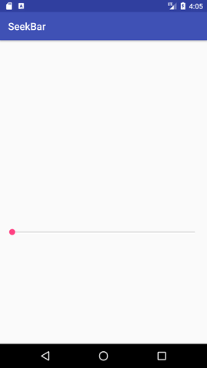
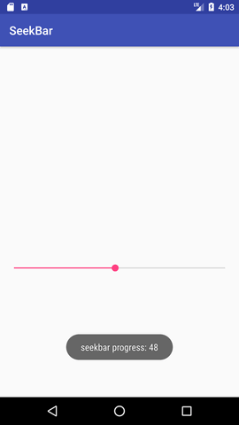
} }) ;} }

Practical No 8 - Registration Form
Activity_main.xml
<?xml version="1.0" encoding="utf-8"?>
<androidx.constraintlayout.widget.ConstraintLayout
xmlns:android="http://schemas.android.com/apk/res/android"
xmlns:app="http://schemas.android.com/apk/res-auto"
android:layout_width="match_parent"
android:layout_height="match_parent"
android:orientation="vertical"
android:padding="20dp">

<TextView
android:id="@+id/textView2"
android:layout_width="215dp"
android:layout_height="47dp"
android:layout_marginTop="52dp"
android:text="LOGIN SCREEN"
android:textSize="30sp"
android:textStyle="bold"
app:layout_constraintEnd_toEndOf="parent"
app:layout_constraintStart_toStartOf="parent"
app:layout_constraintTop_toTopOf="parent" />

<EditText
android:id="@+id/txtEmail"
android:layout_width="370dp"
android:layout_height="51dp"
android:layout_marginTop="108dp"
android:hint="Email"
app:layout_constraintHorizontal_bias="1.0"
app:layout_constraintTop_toTopOf="parent" />

<EditText
android:id="@+id/txtPwd"
android:layout_width="370dp"
android:layout_height="53dp"
android:layout_marginTop="172dp"
android:hint="Password"
android:inputType="textPassword"
app:layout_constraintEnd_toEndOf="parent"
app:layout_constraintHorizontal_bias="0.0"
app:layout_constraintStart_toStartOf="parent"
app:layout_constraintTop_toTopOf="parent" />

<Button
android:id="@+id/btnLogin"
android:layout_width="370dp"
android:layout_height="62dp"
android:layout_marginBottom="392dp"
android:text="Login"
app:layout_constraintBottom_toBottomOf="parent"
app:layout_constraintEnd_toEndOf="parent"
app:layout_constraintHorizontal_bias="0.0"
app:layout_constraintStart_toStartOf="parent" />

<TextView
android:id="@+id/lnkRegister"
android:layout_width="290dp"
android:layout_height="72dp"
android:layout_marginBottom="296dp"
android:text="New here? Register"
android:textColor="#0000FF"
android:textSize="30sp"
app:layout_constraintBottom_toBottomOf="parent"
app:layout_constraintHorizontal_bias="0.493"/>
</androidx.constraintlayout.widget.ConstraintLayout>
Activity_register.xml
<?xml version="1.0" encoding="utf-8"?>
<androidx.constraintlayout.widget.ConstraintLayout
xmlns:android="http://schemas.android.com/apk/res/android"
xmlns:app="http://schemas.android.com/apk/res-auto"
android:layout_width="match_parent"
android:layout_height="match_parent"
android:orientation="vertical"
android:padding="20dp">

<TextView
android:id="@+id/textView"
android:layout_width="236dp"
android:layout_height="43dp"
android:layout_marginTop="76dp"
android:text="REGISTRATION"
android:textSize="30sp"
android:textStyle="bold"
app:layout_constraintEnd_toEndOf="parent"
app:layout_constraintStart_toStartOf="parent"
app:layout_constraintTop_toTopOf="parent" />

<EditText
android:id="@+id/editText"
android:layout_width="354dp"
android:layout_height="54dp"
android:layout_marginTop="132dp"
android:hint="Full Name"
app:layout_constraintEnd_toEndOf="parent"
app:layout_constraintHorizontal_bias="0.647"
app:layout_constraintStart_toStartOf="parent"
app:layout_constraintTop_toTopOf="parent" />

<EditText
android:id="@+id/txtEmail"
android:layout_width="355dp"
android:layout_height="61dp"
android:layout_marginTop="208dp"
android:hint="Email"
app:layout_constraintEnd_toEndOf="parent"
app:layout_constraintHorizontal_bias="0.625"
app:layout_constraintStart_toStartOf="parent"
app:layout_constraintTop_toTopOf="parent" />

<EditText
android:id="@+id/txtPwd"
android:layout_width="351dp"
android:layout_height="62dp"
android:layout_marginTop="284dp"
android:hint="Password"
android:inputType="textPassword"
app:layout_constraintEnd_toEndOf="parent"
app:layout_constraintStart_toStartOf="parent"
app:layout_constraintTop_toTopOf="parent" />

<Button
android:id="@+id/btnRegister"
android:layout_width="355dp"
android:layout_height="67dp"
android:layout_marginBottom="252dp"
android:text="Register Now"
app:layout_constraintBottom_toBottomOf="parent"
app:layout_constraintEnd_toEndOf="parent"
app:layout_constraintStart_toStartOf="parent" />

<TextView
android:id="@+id/lnkLogin"
android:layout_width="205dp"
android:layout_height="55dp"
android:layout_marginBottom="180dp"
android:text="Back to Login"
android:textColor="#0000FF"
android:textSize="30sp"
app:layout_constraintBottom_toBottomOf="parent"
app:layout_constraintEnd_toEndOf="parent"
app:layout_constraintStart_toStartOf="parent" />

</androidx.constraintlayout.widget.ConstraintLayout>

//CODE STARTS HERE
import android.os.Bundle; s // Basic Imports
import android.widget.TextView;
import android.widget.Toast;
import androidx.appcompat.app.AppCompatActivity;
public class MainActivity extends AppCompatActivity {

@Override
protected void onCreate(Bundle savedInstanceState) {
super.onCreate(savedInstanceState);
setContentView(R.layout.activity_main);

showLoginPage(); // Start with the login screen // Code Starts here
}
// Method to show and handle the Login Screen
private void showLoginPage() {
setContentView(R.layout.activity_main); // Load Login XML

TextView btnToRegister = findViewById(R.id.lnkRegister);
btnToRegister.setOnClickListener(v -> showRegisterPage());

findViewById(R.id.btnLogin).setOnClickListener(v ->
Toast.makeText(this, "Login Clicked!", Toast.LENGTH_SHORT).show()); }
// Method to show and handle the Registration Screen
private void showRegisterPage() {
setContentView(R.layout.activity_register); // Load Register XML

TextView btnToLogin = findViewById(R.id.lnkLogin);
btnToLogin.setOnClickListener(v -> showLoginPage());

findViewById(R.id.btnRegister).setOnClickListener(v ->
Toast.makeText(this, "Registered!", Toast.LENGTH_SHORT).show());
}
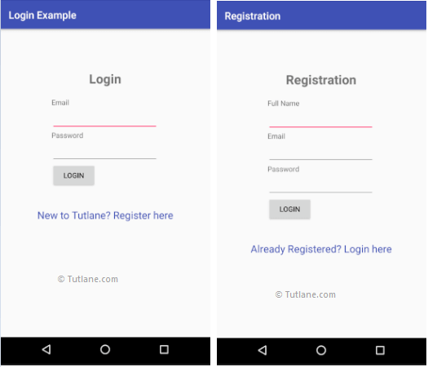
}

Practical no 9 - Date Picker

<?xml version="1.0" encoding="utf-8"?>
<androidx.constraintlayout.widget.ConstraintLayout
xmlns:android="http://schemas.android.com/apk/res/android"
xmlns:app="http://schemas.android.com/apk/res-auto"
xmlns:tools="http://schemas.android.com/tools"
android:id="@+id/main"
android:layout_width="match_parent"
android:layout_height="match_parent"
tools:context=".MainActivity">
<TextView
android:id="@+id/selectedDate"
android:layout_width="347dp"
android:layout_height="95dp"
android:layout_marginTop="40dp"
android:text="Date will appear here"
android:textSize="34sp"
app:layout_constraintHorizontal_bias="0.477"
app:layout_constraintTop_toTopOf="parent" />
<DatePicker <Button
android:id="@+id/datePicker" android:id="@+id/button2"
android:layout_width="271dp" android:layout_width="261dp"
android:layout_height="241dp" android:layout_height="74dp"
android:layout_marginTop="168dp" android:layout_marginBottom="168dp
android:calendarViewShown="false" android:text="Get Date
android:datePickerMode="spinner" app:layout_constraintBottom_toBottomOf="parent
app:layout_constraintEnd_toEndOf="parent" app:layout_constraintStart_toStartOf="parent" />
app:layout_constraintStart_toStartOf="parent"
app:layout_constraintTop_toTopOf="parent" />

// Code starts here // Basic Imports
import android.os.Bundle;
import android.widget.Button;
import android.widget.DatePicker;
import android.widget.TextView;
import androidx.appcompat.app.AppCompatActivity;
public class MainActivity extends AppCompatActivity {
@Override
protected void onCreate(Bundle savedInstanceState) {
super.onCreate(savedInstanceState);
setContentView(R.layout.activity_main);
// S Code
DatePicker picker = findViewById(R.id.datePicker);
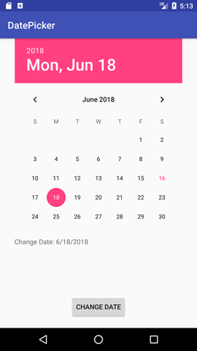
TextView tv = findViewById(R.id.selectedDate);
Button btn = findViewById(R.id.button2);

btn.setOnClickListener(v -> {
// Pulling values directly avoids the API level 26 error
int day = picker.getDayOfMonth();
int month = picker.getMonth() + 1;
int year = picker.getYear();

tv.setText("Date: " + day + "/" + month + "/" + year);
});
}
}

Time Picker
Activity_main.xml –
<?xml version="1.0" encoding="utf-8"?>
<LinearLayout
xmlns:android="http://schemas.android.com/apk/res/android"
android:layout_width="match_parent"
android:layout_height="match_parent"
android:orientation="vertical"
android:gravity="center"
android:padding="20dp">
<TextView
android:id="@+id/selectedTime"
android:layout_width="161dp"
android:layout_height="73dp"
android:text="Pick a Time"
android:textSize="24sp" />
<TimePicker
android:id="@+id/timePicker"
android:layout_width="278dp"
android:layout_height="231dp"
android:timePickerMode="spinner" />
<Button
android:id="@+id/buttonTime"
android:layout_width="366dp"
android:layout_height="80dp"
android:layout_marginTop="10dp"
android:text="Get Time" />
</LinearLayout>

//CODE BEGINS – // Basic Imports
import android.os.Bundle;
import android.widget.Button;
import android.widget.TextView;
import android.widget.TimePicker;
import androidx.appcompat.app.AppCompatActivity;

public class MainActivity extends AppCompatActivity {

@Override
protected void onCreate(Bundle savedInstanceState) {
super.onCreate(savedInstanceState);
setContentView(R.layout.activity_main);

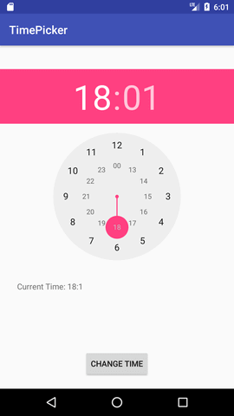
TimePicker tp = findViewById(R.id.timePicker); // S CODE
TextView tv = findViewById(R.id.selectedTime);
Button btn = findViewById(R.id.buttonTime);

btn.setOnClickListener(v -> {
// Use getHour() and getMinute()
int hour = tp.getHour();
int minute = tp.getMinute();
// Simple string to show the time
tv.setText("Time: " + hour + ":" + String.format("%02d", minute));
});
}
}

Practical no 10
Android Progress Bar Example by ProgressDialog
Activity_main.xml
<androidx.constraintlayout.widget.ConstraintLayout
xmlns:android="http://schemas.android.com/apk/res/android"
xmlns:app="http://schemas.android.com/apk/res-auto"
android:layout_width="match_parent"
android:layout_height="match_parent"
android:orientation="vertical">
<Button
android:id="@+id/button"
android:layout_width="161dp"
android:layout_height="107dp"
android:layout_marginBottom="224dp"
android:onClick="startProgress"
android:text="Download Now"
app:layout_constraintHorizontal_bias="0.476"/>
<ProgressBar
android:id="@+id/progressBar"
style="?android:attr/progressBarStyleHorizontal"
android:layout_width="233dp"
android:layout_height="80dp"
android:layout_marginTop="224dp"
app:layout_constraintTop_toTopOf="parent" />
</androidx.constraintlayout.widget.ConstraintLayout>

Code Starts Here
import android.app.ProgressDialog;
import android.os.Bundle;
import android.widget.Button;
import androidx.appcompat.app.AppCompatActivity;
public class MainActivity extends AppCompatActivity {
@Override
protected void onCreate(Bundle savedInstanceState) {
super.onCreate(savedInstanceState);
setContentView(R.layout.activity_main);
Button btn = findViewById(R.id.button);
btn.setOnClickListener(v -> {

// 1. Create and show the dialog
ProgressDialog pd = new ProgressDialog(this);
pd.setProgressStyle(ProgressDialog.STYLE_HORIZONTAL);
pd.setMessage("Loading...");
pd.show();

// 2. Run the progress from 0 to 100
new Thread(() -> {
for (int i = 0; i <= 100; i++) {
pd.setProgress(i);
try { Thread.sleep(50); }
catch (Exception e) {} // Slight delay
}
pd.dismiss(); // Close dialog when loop hits 100
}).start();
});
}
}

